Journal of Computers

Special Issue on Smart Living Technology and Innovations
Call for Papers
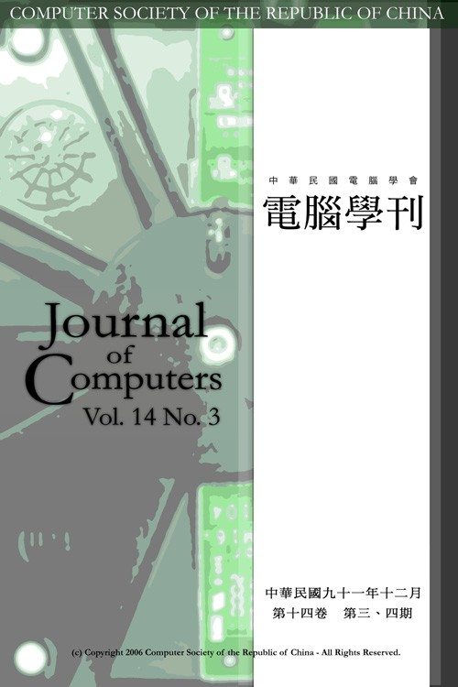

Recently, ad hoc and wireless communication technologies have made available the device, service and information rich environment for the users. Smart Space and ubiquitous computing extend the pervasive computing vision of everyday objects and provide context-awareness services to users in smart living environments. The final goal is to build context-awareness smart space and location-based service applications that integrate information from independent systems which autonomously and securely support human activities.
Smart living technologies may be complex, requiring a systematic approach encompassing vision, needs design, development, technological considerations, implementation, evaluation, and collaboration with other hybrid systems. Creativity, agility, open-mindedness, and innovations are keys to the success of smart space environment construction. However, there are still many research or practice issues can be discussed and improved. The special issue will focus on smart living technology innovations in city, governance, innovation economy, urban infrastructure and personal daily living environment. The topics relevant to this issue include, but are not limited to the following: (1) the impact of new smart living technologies on the design, development and delivery of the above domains; and (2) new AIoT frameworks and Apps for planning and implementing intelligent services for smart living and personal daily living.
This issue recounts how the researchers creates new smart living spaces and service, through the use of smart technologies. This issue illustrates challenges facing the diary living, recounts collaboration with other hybrid systems, and discusses intelligent service provided by information technology. This account contributes to the sharing and discussion of experiences among modern academic scholars regarding needs assessment, planning, and utilization of technology to support smart services. This issue aims to cover both technological as well as non-technological issues related to these rapidly evolving and growing areas. Hence, this issue invites papers to the following topics, but never exclusive:

Topics
- Application Areas
  - Smart City
  - Smart Governance
  - Smart Home
  - Smart Innovation Economy
  - Smart Learning
  - Smart Urban infrastructure
  - Smart Space
- Techniques
  - Ambient Intelligence
  - Context-Aware Computing
  - Deep Learning
  - Embedded Systems and Devices
  - Evolving Soft Computing Techniques
  - Human-to-Computer Interfaces
  - Innovative Sensing Devices and Applications
  - Machine Learning and Vision
  - Middleware and Architectures
  - Modeling environments and Human Behavior
  - Sensor Networks, Mobile Ad Hoc Networks
  - Security, Privacy and Trust

Important dates
- Submission due: 31 July, 2019
- Notification of final acceptance: 30 Sepetmber, 2019
- Final papers: Q4 2019 or Q1 2020

Submission
Submissions to the special issue will be screened by the Special Issue Editor to insure that they conform to the quality standards of Journal of Computers. Papers that do not pass this initial screening will be immediately returned to the authors. Reviewers will apply those standards in forming recommendations for acceptance, revision, or rejection. A maximum of two revisions will be invited. Papers should be formatted with Journal of Computers style (http://www.csroc.org.tw/journal/JOC%20Format%20(English)/new_JOC_typeinst.doc). The submission deadline is 31 July, 2019. The prospective contributors should submit their papers directly to the online submission system (http://www.csroc.org.tw/journal/E_howsub.htm). In addition, Authors please note the Special Issue (Smart Living Technology and Innovations).

Guest Editor

Mu-Yen Chen, Ph.D.
Department of Information Management
National Taichung University of Science and Technology, Taiwan
E-mail: mychen@nutc.edu.tw

Long-Sheng Chen
Department of Information Management
Chaoyang University of Technology, Taiwan
E-mail: lschen@cyut.edu.tw

Feng-Cheng Lin
Department of Information Engineering and Computer Science
Feng Chia University
E-mail: fclin@fcu.edu.tw

